**TRAFFIC FLOW MANAGEMENT SYSTEM (TFMS)**

**Introduction**

The increasing volume of traffic on roads has led to congestion, accidents, and air pollution, making traffic management a critical concern for urban planners and authorities. To address these challenges, Traffic Flow Management Systems (TFMS) have emerged as a promising solution. TFMS is a comprehensive system that integrates real-time traffic data, advanced analytics, and intelligent transportation systems to optimize traffic flow, reduce congestion, and improve safety. By leveraging cutting-edge technologies such as IoT sensors, artificial intelligence, and data analytics, TFMS enables traffic managers to make informed decisions, respond to incidents in real-time, and provide a smoother, more efficient travel experience for commuters.

**More detailed and comprehensive response to the ER Diagram question:**

**Task 1:** **Entity Identification and Attributes**

**The following entities are relevant to the TFMS:**

**Roads**

RoadID (PK): unique identifier for each road

RoadName: name of the road

Length: length of the road in meters

SpeedLimit: speed limit on the road in km/h

RoadType: type of road (e.g., highway, local road, pedestrian path)

RoadCondition: current condition of the road (e.g., good, bad, under construction)

**Intersections**

IntersectionID (PK): unique identifier for each intersection

IntersectionName: name of the intersection

Coordinates: geographic coordinates (Latitude, Longitude) of the intersection

IntersectionType: type of intersection (e.g., traffic light, roundabout, pedestrian crossing)

**Traffic Signals**

SignalID (PK): unique identifier for each traffic signal

IntersectionID (FK): references the intersection where the signal is located

SignalStatus: current status of the signal (Green, Yellow, Red)

Timer: countdown to the next signal change

SignalType: type of signal (e.g., traffic light, pedestrian signal)

**Traffic Data**

TrafficDataID (PK): unique identifier for each traffic data entry

RoadID (FK): references the road where the data was collected

Timestamp: timestamp of the data collection

Speed: average speed on the road

CongestionLevel: degree of traffic congestion (e.g., low, medium, high)

Volume: number of vehicles on the road

**Route Optimization**

RouteID (PK): unique identifier for each optimized route

Origin: starting point of the route

Destination: ending point of the route

RouteDistance: total distance of the route

RouteTime: estimated time to complete the route

RouteInstructions: turn-by-turn instructions for the route

**Task 2:** **Relationship Modeling**

**The relationships between entities are as follows:**

A road can have multiple intersections (one-to-many).

A road can have multiple intersections, but an intersection is only associated with one road.

An intersection is located at the junction of multiple roads (many-to-many).

An intersection can be located at the junction of multiple roads, and a road can be part of multiple intersections.

An intersection has one traffic signal (one-to-one).

An intersection has only one traffic signal, and a traffic signal is only associated with one intersection.

A traffic signal is located at one intersection (one-to-one).

A traffic signal is only located at one intersection, and an intersection has only one traffic signal.

Traffic data is collected on a specific road (one-to-many).

Traffic data is collected on a specific road, and a road can have multiple traffic data entries.

A route optimization is based on traffic data (many-to-many).

A route optimization can be based on multiple traffic data entries, and a traffic data entry can be used in multiple route optimizations.

**Task 3: ER Diagram Design**

***Here is the ER diagram for the TFMS:***

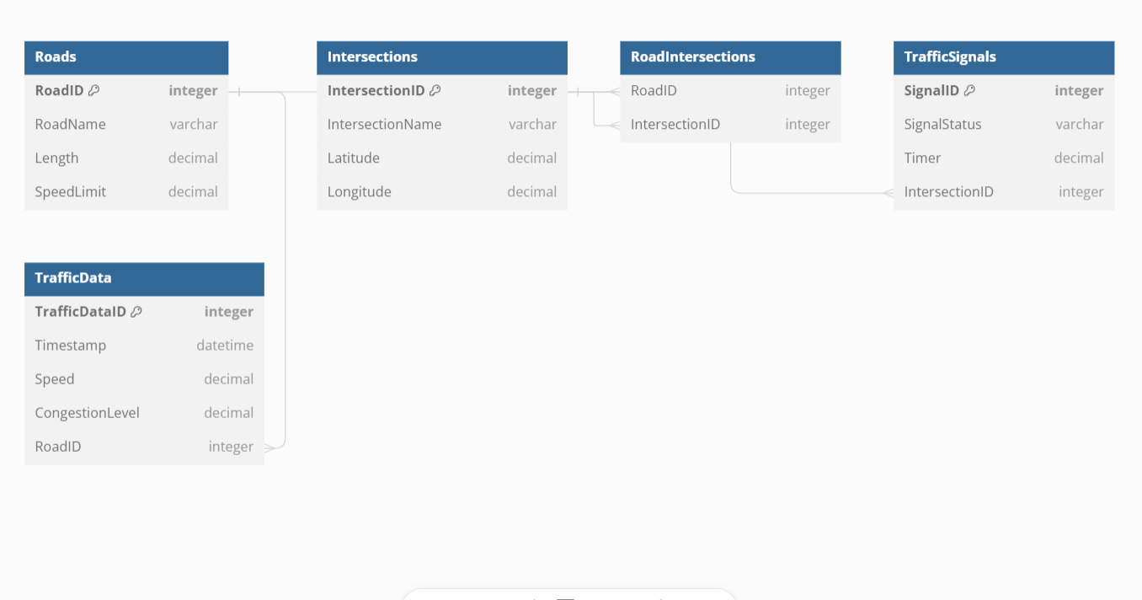

***Certainly code for this would be :***

Table Roads {

  RoadID integer [primary key]

  RoadName varchar

  Length decimal

  SpeedLimit decimal

}

Table Intersections {

  IntersectionID integer [primary key]

  IntersectionName varchar

  Latitude decimal

  Longitude decimal

}

Table RoadIntersections {

  RoadID integer [ref: > Roads.RoadID]

  IntersectionID integer [ref: > Intersections.IntersectionID]

}

Table TrafficSignals {

  SignalID integer [primary key]

  SignalStatus varchar

  Timer decimal

  IntersectionID integer [ref: > Intersections.IntersectionID]

}

Table TrafficData {

  TrafficDataID integer [primary key]

  Timestamp datetime

  Speed decimal

  CongestionLevel decimal

  RoadID integer [ref: > Roads.RoadID]

}

**Task 4:** **Justification and Normalization**

The ER diagram design choices ensure scalability, real-time data processing, and efficient traffic management. The use of primary and foreign keys establishes clear relationships between entities, minimizing redundancy and improving data integrity.

**To ensure normalization, the following principles are adhered to:**

**First Normal Form (1NF):** Each table cell contains a single value, and each column contains only atomic values. In this design, each column in each table contains a single value, and there are no repeating groups or arrays.

**Second Normal Form (2NF):** Each non-key attribute in a table depends on the entire primary key. In this design, the primary keys are composite keys, ensuring that each non-key attribute depends on the entire primary key.

**Third Normal Form (3NF):** If a table is in 2NF, and a non-key attribute depends on another non-key attribute, then it should be moved to a separate table. In this design, there are no transitive dependencies, ensuring 3NF compliance.

**The ER diagram is designed to support the key functionalities of the TFMS, including:**

***Route Optimization:*** The ER diagram allows for the storage of traffic data and route optimization results, enabling the system to suggest optimal routes based on current traffic conditions.

***Traffic Signal Control:*** The ER diagram enables the storage of traffic signal status and timer information, allowing the system to adjust signal timings dynamically based on real-time traffic flow and congestion data.

***Historical Analysis:*** The ER diagram allows for the storage of historical traffic data, enabling the system to analyze and plan for future improvements.

**Design Choices and Justification:**

**The design choices made in this ER diagram are justified by the following considerations:**

**Scalability:** The use of separate tables for roads, intersections, traffic signals, and traffic data enables the system to handle large amounts of data and scale efficiently.

**Real-time Data Processing:** The design allows for real-time data processing and analysis, enabling the system to respond quickly to changing traffic conditions.

**Efficient Traffic Management:** The ER diagram enables the system to optimize traffic flow and reduce congestion, improving overall traffic management efficiency.

**Normalization Considerations**

**To ensure data integrity and minimize redundancy, the following normalization considerations were made:**

***Eliminating Redundancy*:** The design eliminates redundancy by storing each piece of data in one place and one place only.

***Improving Data Integrity:*** The use of primary and foreign keys ensures data integrity by preventing inconsistent data entries.

***Reducing Data Duplication:*** The design reduces data duplication by storing data in separate tables, rather than duplicating data across multiple tables.

**Conclusion**

The ER diagram designed for the TFMS meets the requirements of the system, ensuring scalability, real-time data processing, and efficient traffic management. The design choices made are justified by the need to support key functionalities, and the normalization considerations ensure data integrity and minimize redundancy.